Buying House Management System

**Letter of Transmittal**

16 January,2025

To

ASM Shakil Ahamed

Senior Lecturer

Department of Computer Science and Engineering

IUBAT– International University of Business Agriculture and Technology

4 Embankment Drive Road, Sector 10, Uttara Model Town

Dhaka 1230, Bangladesh

Subject: Letter of Transmittal

Dear Sir,

Thank you for assigning us such an abrasive topic. We have tried our best to make the project successful on time although there were some limitations. After completing all the work. We have written this report, which will help you to know about our project. It is expected that the report will tell that to focus on Buying House Management System details. We hope you will find the report relevant and meaningful.

Sincerely,

Tonmoy Sarker (22203004)

**Abstract**

A Buying House Management System is a comprehensive software solution designed to streamline and enhance the operations of a buying house involved in sourcing, quality control, order management, and communication between manufacturers and buyers. This system simplifies complex workflows by automating processes such as product inquiry, order placement, vendor management, production tracking, shipment scheduling, and documentation. It offers a centralized platform to manage data, monitor progress in real-time, and ensure compliance with quality standards. With features like role-based access, reporting, and analytics, this system improves efficiency, reduces errors, and fosters seamless collaboration among stakeholders, ultimately enhancing operational effectiveness and customer satisfaction.

**Acknowledgement**

First of all, we sincerely we would like to pay our gratitude to our project advisor ASM Shakil Ahamed, Senior Lecturer, Department of CSE, IUBAT, who has given us the opportunity to make such a report for not only in this semester but also throughout our education life at real sectors by giving his valuable suggestion and advises at any time any situation. For his right direction we would be able to make this report.

**Declaration**

We, Tonmoy Sarker (22203004)

Student of BSc in Computer Science & Engineering of IUBAT declaring that,

this report on the topic of “Buying House Management System “has been prepared for the fulfilment of the project course CSC 387.

CSC 387, project as well as the practical requirement of BSc in Computer Science & Engineering degree.

The report and the project on “Buying House Management System “ is originally prepared by us .All module and procedure of this project is being made after proper inspection and internet information.

It has not been prepared for any other purposes, rewards or presentations.

----------------------------------

Tonmoy Sarker

Program: BCSE

ID:22203004

**Letter Of Authorization**

**“Content Page”**

1. **INTRODUCTION**
2. **AIM**
3. **ADMINISTRATIVE MODULE**
4. **SYSTEM STUDY AND ANALISIS**
   1. **SYSTEM ANALYSIS**
   2. **EXISTING SYSTEM**
   3. **PROPOSED SYSTEM**
   4. **FEASIBILITY STUDY**
5. **SYSTEM DESIGN**
   1. **INTRODUCTION**
   2. **LOGICAL DESIGN**
   3. **PHYSICAEFFORTL DESIGN**
   4. **DESIGN ACTIVITIES**
   5. **DATABASE DESIGN**
   6. **IDENTIFYING ENTITIES**
   7. **ENTITY ERLATIONSHIP DIAGRAM**
   8. **DATABASE TABLE STRACTURE**
6. **SYSTEM DESCRIPTION** 
   1. **DATA FLOW DIAGRAM**
   2. **DATA FLOW DIAGRAM FOR BUYING HOUSE MANAGEMENT SYSTEM**
7. **EFFORT DISTRIBUTION**
8. **SYSTEM SPECIFICATION**
9. **PROJECT COST ESTIMATION**
10. **SYSTEM IMPLIMENTATION AND TESTING** 
    1. **SYSTEM TESTING**
    2. **TEST PLAN**
11. **TRAINNING**
12. **SCREEN SHOTS**
13. **CONCLUSION**

**--PROJECT--**

1. **INTRODUCTION**

The Buying House Management System is a software application designed to assist buying houses in managing their day-to-day operations efficiently. Buying houses act as intermediaries between manufacturers and buyers, ensuring the smooth execution of activities such as product sourcing, quality assurance, order tracking, and shipment management. This project aims to provide a centralized platform to streamline these processes, reduce manual effort, and enhance communication among stakeholders

1. **AIM**

The aim of the project is to develop a user-friendly and efficient system that automates and manages the core functions of a buying house. The system will simplify operations such as order management, production tracking, vendor coordination, and reporting, ensuring timely delivery of quality products while improving overall productivity and transparency.

1. **ADMINISTRATIVE MODULE**

This module is the main module which performs all the main operations in the system .The major operations are :

* Order
* Payment
* Category
* Inventory

1. **SYSTEM STUDY AND ANALISIS**

**4.1. SYSTEM ANALYSIS**

System analysis is a critical phase of the software development lifecycle that involves understanding the requirements, evaluating existing systems, and defining the goals and constraints of the proposed system. This analysis ensures that the Buying House Management System meets the needs of all stakeholders effectively. Buying houses often struggle with managing complex operations such as product sourcing, order tracking, vendor communication, and quality assurance due to reliance on manual processes or disconnected tools. These inefficiencies result in errors, communication gaps, missed deadlines, and client dissatisfaction. The Buying House Management System aims to address these challenges by automating and streamlining operations, providing a centralized platform for managing orders, vendors, and communications, enabling real-time updates and monitoring, generating accurate reports for decision-making, and enhancing collaboration among stakeholders to improve overall efficiency and transparency.

**4.2. EXISTING SYSTEM**

Current System:

* Most buying houses use spreadsheets, emails, or standalone tools to manage operations.
* Manual processes are time-consuming, prone to errors, and lack transparency.
* Communication between stakeholders is often fragmented, leading to delays and misunderstandings.

Limitations:

* No centralized data repository for easy access and tracking.
* Difficulty in monitoring order progress in real-time.
* Inefficient reporting and data analysis capabilities.
* Limited collaboration tools for internal and external communication.

**4.3. PROPOSED SYSTEM**

Key Features:

* Centralized database for storing all data related to orders, vendors, buyers, and shipments.
* Automated workflows for order management, production tracking, and quality control.
* Role-based access to ensure data security and confidentiality.
* Real-time notifications and alerts for task updates and critical deadlines.
* Comprehensive reporting and analytics tools for performance evaluation.

Advantages:

* Improved efficiency and accuracy in operations.
* Enhanced communication and collaboration among stakeholders.
* Real-time monitoring of orders and shipments to ensure timely delivery.
* Reduced manual effort and operational costs.

**4.4. FEASIBILITY STUDY**

Technical Feasibility:

The system can be developed using modern technologies such as web-based platforms, cloud databases, and secure APIs for integration. These technologies ensure scalability, reliability, and ease of access.

Operational Feasibility:

The system aligns with the workflows of buying houses, making it easy to adopt. Training sessions can be provided to ensure smooth implementation.

Economic Feasibility:

Although there is an initial investment in system development and training, the long-term benefits, such as reduced errors and operational costs, outweigh the expenses.

1. **SYSTEM DESIGN**

**5.1. INTRODUCTION**

The System Redesign Report for the Buying House Management System outlines the need for restructuring and improving the existing system to address operational inefficiencies and enhance functionality. As buying houses play a pivotal role in bridging manufacturers and buyers, their operations involve intricate processes like order management, production tracking, quality assurance, and shipment coordination. The current system, heavily reliant on manual workflows or disconnected tools, often results in errors, delays, and communication gaps.

This redesign project focuses on reimagining the system to incorporate advanced technology, automate repetitive tasks, and provide a centralized platform for seamless communication and real-time data tracking. By leveraging user feedback, analysing shortcomings of the current system, and incorporating modern software solutions, the redesigned system aims to improve efficiency, transparency, and user experience while aligning with the growing demands of the industry.

**5.2 LOGICAL DESIGN**

**5.3. PHYSICAL DESIGN**

**5.4. DESIGN ACTIVITIES**

**5.5. DATABASE DESIGN**

**5.6. IDENTIFYING ENTITIES**

Identifying the entities according to the conceptual Design:

* 1. Brand
  2. Size
  3. Category
  4. Product
  5. Order Status
  6. Order
  7. User
  8. Price

**5.7. ENTITY ERLATIONSHIP DIAGRAM**

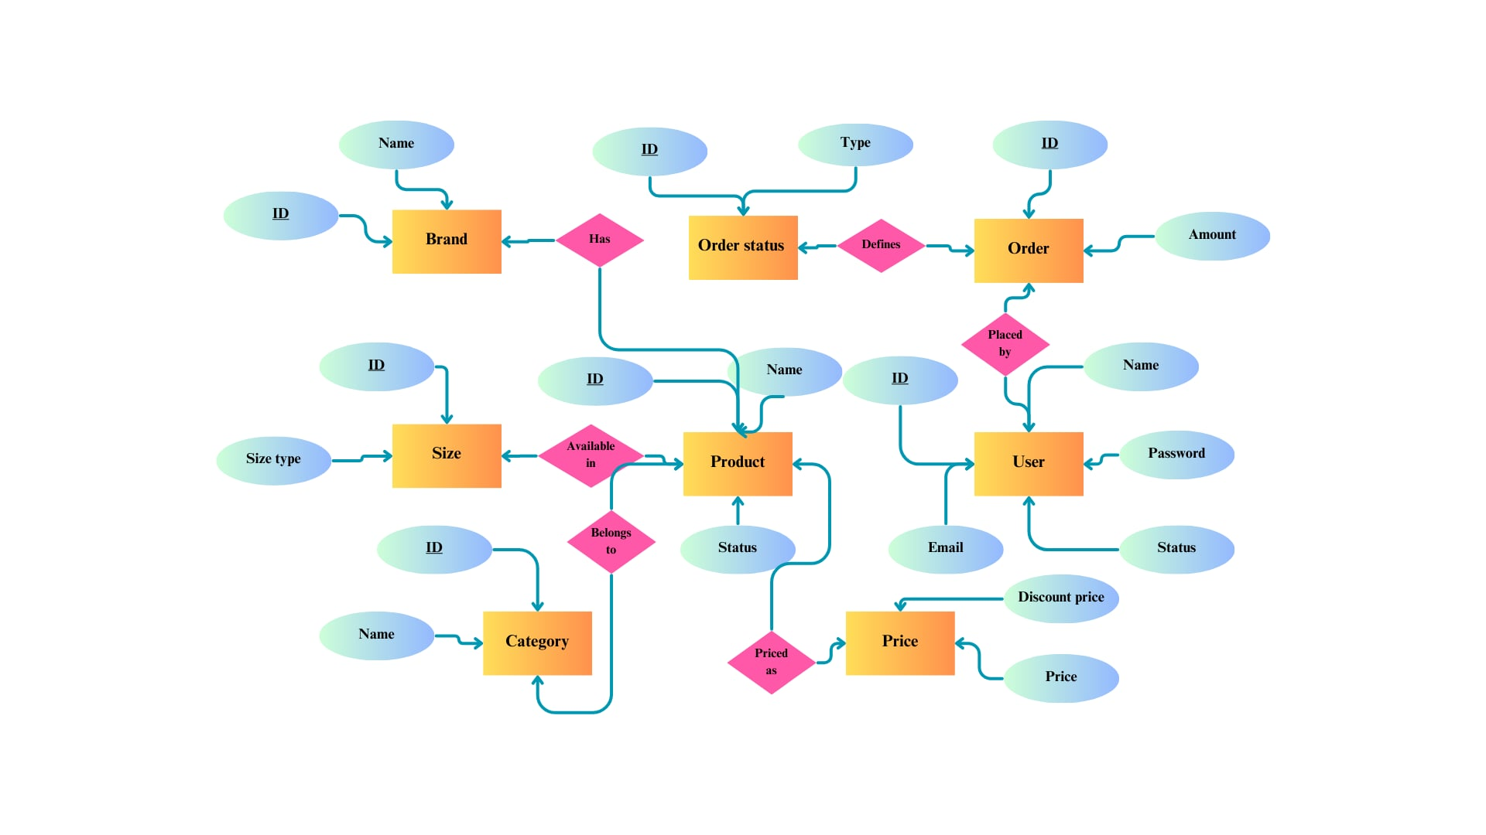

**5.8. DATABASE TABLE STRACTURE**

1. **SYSTEM DESCRIPTION**

To develop the Buying House Management System, several modules are designed to manage the diverse and interconnected functions required by buying houses. The primary components (modules) of the system are listed below:

1. User Management
2. Order Management
3. Category Management
4. Product Management
5. Inventory Management

**User Management:**

This module provides a secure and role-based access system for different stakeholders such as administrators, buyers, vendors, and employees. Key features include:

* Creating and managing user accounts.
* Assigning specific roles and permissions.
* Monitoring user activity for accountability and security.
* Ensuring data access is limited based on user roles.

**Order Management:**

The Order Management module is the core of the system, facilitating the smooth handling of orders from initiation to delivery. Key functionalities include:

* Creating, tracking, and updating order details.
* Assigning orders to production teams, quality controllers, or vendors.
* Monitoring the status of orders in real-time to ensure deadlines are met.
* Generating order progress reports and alerts for delayed tasks.

**Category Management:**

This module organizes products and items into categories to streamline sourcing and ordering processes. Key features include:

* Defining and managing product categories based on type, material, or purpose.
* Allowing vendors and buyers to search and filter products by category.
* Simplifying inventory organization through category classification.

**Product Management:**

The Product Management module handles all product-related data, ensuring accurate information is available for orders and inventory. Features include:

* Adding, updating, and deleting product details (e.g., specifications, pricing, and images).
* Associating products with their respective categories.
* Tracking product availability and linking them to orders.

**Inventory Management:**

The Inventory Management module keeps track of stock levels, ensuring that products and raw materials are available as needed. Features include:

* Maintaining real-time inventory records for in-stock and out-of-stock items.
* Generating alerts for low stock levels.
* Managing procurement and updating stock levels upon receipt of goods.
* Providing reports on inventory usage and trends to improve stock planning.

**Integrated Functionality:**

These modules work in synergy to streamline buying house operations. For example, the Order Management module integrates with Inventory Management to ensure the availability of products and raw materials, while Product Management ties into both Category Management and Inventory Management for accurate tracking and organization.

This structured approach ensures the efficient operation of the buying house, minimizes errors, and fosters better communication and decision-making across all levels of the organization.

**6.1. DATA FLOW DIAGRAM FOR BUYING HOUSE MANAGEMENT SYSTEM**

**Level 0**

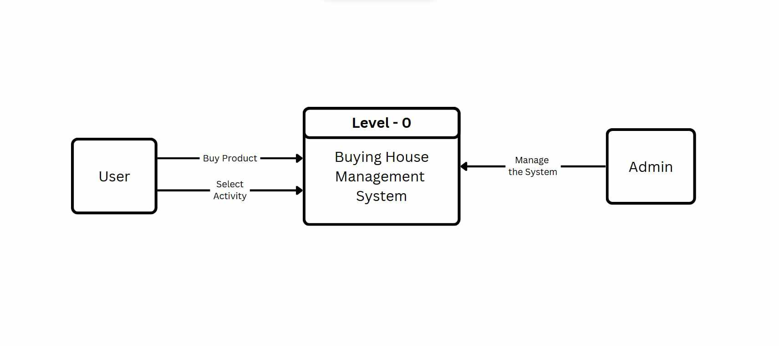

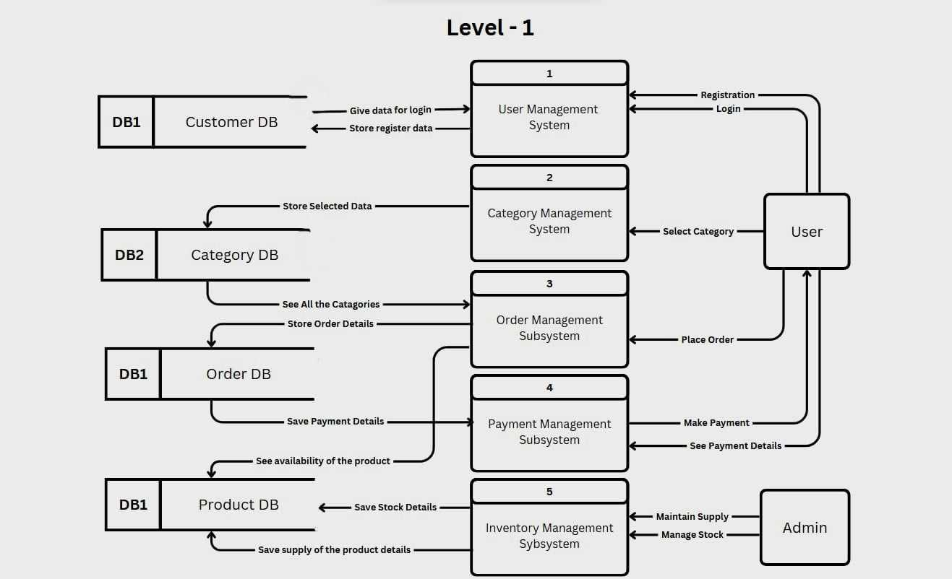

1. **EFFORT DISTRIBUTION**

**7.1. Task Scheduling**

Task scheduling is an essential activity in distributing the estimated efforts within the planned project timeline. It ensures that every task is organized, efficient, and aligned with the project goals. The following basic rules are applied to task scheduling in this project:

* **Compartmentalization**:

The project is divided into a series of manageable activities and tasks. Each task is structured to ensure smooth execution and easier tracking.

* **Interdependency**:

The relationship between various tasks is identified to understand which tasks must occur sequentially and which can run in parallel. This interdependency ensures logical task flow.

* **Time Allocation:**

Every task is assigned a specific duration to ensure efficient use of resources and adherence to the overall project schedule.

* **Effort Validation**:

Each project is developed with a specific number of staff members. However, in this case, the system is developed individually for the course requirement. For group projects, it is crucial to ensure that no task exceeds the allocated resources or workforce at any given time.

* **Defined Responsibilities**:

Each scheduled task is assigned to a specific individual or role to ensure maximum accountability and productivity.

* **Defined Outcomes**:

Every scheduled task is tied to a clear and measurable outcome. These outcomes typically represent deliverables or components of the final project, ensuring that each task contributes meaningfully to the overall objective.

**7.2 Time Chart for Activity:**

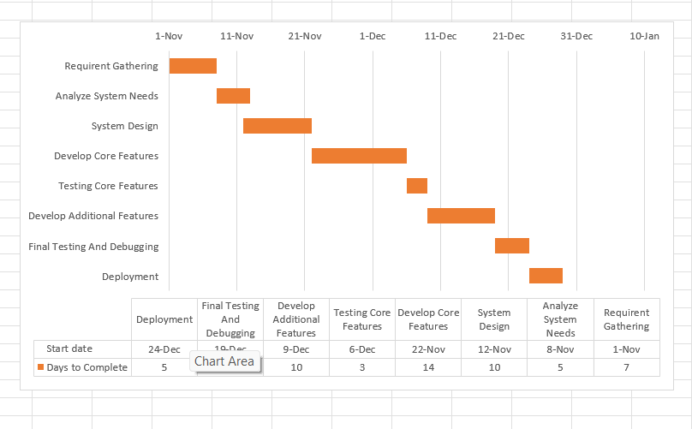

1. **SYSTEM SPECIFICATION**

**8.1. Hardware Requirements:**

Motherboard :

Processor :

RAM :

HDD :

Monitor :

Keyboard :

Mouse :

**8.2. Software Requirements**

Operating System:

Front-end:

Back-end:

1. **PROJECT COST ESTIMATION**
2. **SYSTEM IMPLIMENTATION AND TESTING**

System Implementation is the phase where the designed system is developed, integrated, and deployed. For the Buying House Management System, this involves translating the design into functional modules and ensuring that all features work as intended. This stage is followed by thorough testing to identify and resolve any issues before the system goes live.

Steps in system implementation include:

1. Development:
   * Writing code for the modules (User Management, Order Management, etc.).
   * Integrating databases, user interfaces, and backend systems.
   * Configuring the system to meet project requirements.
2. Integration:
   * Ensuring all modules (e.g., Inventory Management, Product Management) work seamlessly together.
   * Testing data flow between modules to maintain consistency.
3. Deployment:
   * Installing the system in a test environment to verify its functionality.
   * Gradual deployment to ensure smooth transition to the live environment.

System Testing ensures the functionality, performance, and reliability of the developed system. It validates whether the system meets the specified requirements and performs as expected under different conditions.

**10.1. SYSTEM TESTING**

System testing involves evaluating the entire system to detect errors, gaps, or unmet requirements. The key objectives are:

* To verify that the system works as per the design specifications.
* To ensure the system is stable, secure, and user-friendly.
* To test the interaction between modules for consistency.

Types of System Testing:

1. **Functional Testing**: Ensures the system performs the required functions (e.g., managing orders, updating inventory).
2. **Integration Testing**: Verifies the interaction between different modules, such as data flow between Order Management and Inventory Management.
3. **Performance Testing**: Checks the system’s responsiveness and stability under load (e.g., multiple users accessing the system simultaneously).
4. **User Acceptance Testing (UAT)**: Involves end-users testing the system to ensure it meets their requirements and expectations.
5. **Security Testing**: Ensures that the system protects sensitive data and resists unauthorized access.

**10.2.TEST PLAN**

A **Test Plan** outlines the strategy, resources, and schedule for testing the Buying House Management System. It defines the scope, objectives, and deliverables of the testing phase.

**1. Objectives**:

* Ensure all modules work correctly and meet user requirements.
* Identify and fix bugs before deployment.
* Validate system performance, security, and usability.

**2. Scope**:

* Testing of all core modules: User Management, Order Management, Product Management, Inventory Management, and Category Management.
* Ensuring the system integrates with third-party tools .

**3. Test Environment**:

* Test environment will simulate the live environment with sample data.
* Test cases will be executed on different devices, browsers, or operating systems .

**4. Test Cases**:  
Examples of test cases include:

* Verifying user login and role-based access control.
* Creating, updating, and deleting orders in the Order Management module.
* Checking inventory updates after an order is processed.
* Ensuring reports generate accurate data.

**5. Testing Tools**:

* Manual testing tools for functional and integration tests.
* Performance testing tools to simulate load conditions.

**6. Schedule**:  
Testing will be conducted in phases:

* Unit Testing: Individual modules are tested during development.
* System Testing: All modules are tested together in a test environment.
* User Acceptance Testing (UAT): Final testing by stakeholders before deployment.

**7. Deliverables**:

* Test report detailing test cases executed, results, and identified issues.
* A list of resolved issues and validation of fixes.

1. **TRAINNING**

Once the system is successfully developed, the next critical step is to ensure that the administrators and users are well-trained to handle the system. This is because the success of any system largely depends on how it is operated and used. Proper implementation involves assigning the right people to the right tasks and ensuring they are equipped with the necessary skills. Training ensures that users feel confident in utilizing the system efficiently, leading to optimal performance.

Implementation is the phase where the theoretical design is turned into a working system. Through training, users gain confidence in the system’s capability to function as intended. Without adequate training, effective system implementation is not possible.

The system personnel check the feasibility of the system during this phase. Sample data is input into the system to test its functionality, and the working of the system is monitored closely. For testing, the master options are selected from the main menu, and relevant data is entered into the system screens. Data validation is performed to ensure its accuracy. Various reports, such as inventory and order reports, are generated during this phase, with their formats evaluated for usability and clarity. The results of these tests are documented for reference.

Implementation Walkthroughs:

Walkthroughs are conducted to ensure that the system solves the original problem effectively. These sessions take place before the system is deployed for live use. They include a comprehensive review of all manuals, training materials, and system documentation. All relevant stakeholders, including system analysts and support staff, participate in these walkthroughs to familiarize themselves with the process.

Training Sessions:

Training sessions are planned and executed to help users and administrators become familiar with the system. These sessions focus on simplifying complex tasks and empowering users to operate the system effectively without the need for technical assistance.

Training includes:

1. Workshops: Workshops are conducted to cover critical aspects such as user roles, data backup, system security, and troubleshooting.
2. User Manuals: Detailed user manuals are created, outlining step-by-step procedures for handling system functions. These manuals are written in simple language for ease of understanding.

Through proper training, the implementation process is streamlined, ensuring smooth adoption and continued system maintenance by the organization’s staff.

1. **SCREEN SHOTS**
2. **CONCLUSION**

The **Buying House Management System** has been developed to address the complexities and inefficiencies of managing a buying house. By integrating various modules such as User Management, Order Management, Product Management, and Inventory Management, the system streamlines operations, enhances accuracy, and improves overall productivity. This system provides a centralized platform for managing critical business processes, ensuring effective communication and collaboration across departments.

The implementation of this system marks a significant improvement over traditional manual methods, offering automation, reliability, and real-time data access. Extensive testing and training have ensured that the system meets the project’s requirements and is user-friendly for all stakeholders involved.

The successful completion of this project demonstrates the effectiveness of structured design, implementation, and testing methodologies. By embracing this system, the buying house can achieve better resource utilization, faster decision-making, and improved customer satisfaction. Moving forward, the system can be further enhanced with additional features and scalability to meet future business needs.

This project not only fulfils its objective of providing a robust management system but also highlights the potential of leveraging technology to solve real-world business challenges.